Chapter 15 Oligopoly

15.1 What Is Oligopoly?

1) The market structure in which natural or legal barriers prevent the entry of new firms and a small number of firms compete is
A) monopoly.
B) monopolistic competition.
C) perfect competition.
D) oligopoly.
E) imperfect monopoly.
Answer: D
Diff: 1 Type: MC
Topic: What Is Oligopoly?

2) Suppose that industry A consists of four firms who collectively control 96 percent of total sales in the market. We can conclude that industry A is
A) perfectly competitive.
B) a duopoly.
C) monopolistically competitive.
D) an oligopoly.
E) a monopoly.
Answer: D
Diff: 2 Type: MC
Topic: What Is Oligopoly?

3) Which one the following industries is the best example of an oligopoly?
A) the market for wheat
B) the fast-food industry
C) the automobile industry
D) the clothing industry
E) the restaurant industry
Answer: C
Diff: 1 Type: MC
Topic: What Is Oligopoly?

4) Which one of the following industries is the best example of an oligopoly?
A) the battery industry
B) the sporting goods industry
C) the footwear industry
D) the cosmetics industry
E) the power industry
Answer: A
Diff: 1 Type: MC
Topic: What Is Oligopoly?
5) Which one of the following characteristics applies to oligopolistic markets?
A) There is a large number of firms.
B) The absence of barriers to entry of firms.
C) Firms are large relative to the size of the market.
D) All firms are price takers.
E) Firms produce only differentiated products.
Answer: C
Diff: 1 Type: MC
Topic: What Is Oligopoly?

6) Which one of the following characteristics applies to oligopolistic markets?
A) There is free entry of rival firms.
B) Firms are so large relative to the market that they do not have to consider the behaviour of rival firms.
C) Firms are mutually independent because there are many firms in the industry.
D) Firms have to consider the behaviour of their rivals since their rivals are also large relative to the size of the market as a whole.
E) Economic profit of each firm equals zero.
Answer: D
Diff: 2 Type: MC
Topic: What Is Oligopoly?

7) Why might only a few firms dominate an oligopolistic industry?
A) A natural or legal barrier to entry exists.
B) Perfectly elastic demand makes small-scale operation economically inefficient.
C) Decreasing returns to scale may make small-scale firms more advantageous.
D) Inelastic market demand leads to the domination of the industry by a few firms.
E) It is due to the outcome of the prisoners' dilemma.
Answer: A
Diff: 2 Type: MC
Topic: What Is Oligopoly?

8) Which is not a characteristic of oligopoly?
A) Each firm faces a downward-sloping demand curve.
B) Firms are profit-maximizers.
C) The sales of one firm will not have a significant effect on other firms.
D) There is more than one firm in the industry.
E) Firms set prices.
Answer: C
Diff: 2 Type: MC
Topic: What Is Oligopoly?

9) If the efficient scale of production only allows three firms to supply a market, the market is a
A) three-firm monopoly.
B) cost-based oligopoly.
C) natural oligopoly.
D) monopolistic competition.
E) competitive monopoly.
Answer: C
Diff: 1 Type: MC
Topic: What Is Oligopoly?
10) A cartel is a group of firms which agree to
A) behave competitively.
B) raise the price of their products.
C) lower the price of their products.
D) increase the amount they produce.
E) cheat on each other.
Answer: B
Diff: 1 Type: MC
Topic: What Is Oligopoly?

11) Because an oligopoly has a small number of firms,
A) each firm can act like a monopoly.
B) the firms may legally form a cartel.
C) the HHI for the industry is small.
D) the four-firm concentration ratio for the industry is small.
E) the firms are interdependent.
Answer: E
Diff: 1 Type: MC
Topic: What Is Oligopoly?

12) A duopoly is
A) a market where three dominant firms collude to decide the profit-maximizing price.
B) a market where two firms compete for profit and market share.
C) the same as a monopoly.
D) not an oligopoly.
E) a market with two distinct products.
Answer: B
Diff: 1 Type: MC
Topic: What Is Oligopoly?

13) A duopoly occurs when
A) there are only two producers of a particular good competing in the same market.
B) there are two producers of two goods competing in an oligopoly market.
C) there are numerous producers of two goods competing in a competitive market.
D) the one producer of two goods sells the goods in a monopoly market.
E) a competitive market produces two goods.
Answer: A
Diff: 1 Type: MC
Topic: What Is Oligopoly?
Use the figure below to answer the following question.

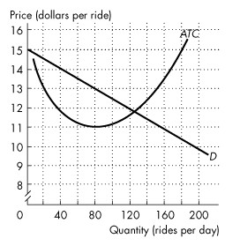
Figure 15.1.1

In the figure, D is the demand curve for taxi rides in a town, and ATC is the average total cost curve of a taxi company.

14) Refer to Figure 15.1.1. In the scenario above, the market is
A) a natural duopoly.
B) a natural oligopoly with three firms.
C) a natural monopoly.
D) monopolistically competitive.
E) perfectly competitive.
Answer: A
Diff: 2 Type: MC
Topic: What Is Oligopoly?

15) A monopolistically competitive firm is like an oligopolistic firm insofar as
A) both face perfectly elastic demand.
B) both can earn an economic profit in the long run.
C) both have MR curves that lie beneath their demand curves.
D) neither is protected by high barriers to entry.
E) both are price takers.
Answer: C
Diff: 2 Type: MC
Topic: What Is Oligopoly?
16) An oligopoly is a market structure in which there
A) are a few buyers but many sellers.
B) are no barriers to entry.
C) are many independent sellers.
D) are a few goods sold by many sellers.
E) is a temptation to collude.
Answer: E
Diff: 1 Type: MC
Topic: What Is Oligopoly?

17) The distinguishing features of oligopoly are ________ and ________ in the industry.
A) no barriers to entry; a small number of firms
B) barriers to entry; a large number of firms
C) no barriers to entry; a large number of firms
D) barriers to entry; one firm
E) barriers to entry; a small number of firms
Answer: E
Diff: 2 Type: MC
Topic: What Is Oligopoly?

18) Oligopoly is similar to
A) perfect competition because both market types produce identical goods.
B) perfect competition because both firms in both market types make zero economic profit in the long run.
C) monopoly because both market types have barriers to entry.
D) monopoly because both market types have a single firm.
E) monopolistic competition because firms in both markets face a perfectly elastic demand.
Answer: C
Diff: 1 Type: MC
Topic: What Is Oligopoly?

19) In an oligopoly market, the Herfindahl-Hirschman Index is usually
A) below 2,500.
B) zero.
C) above 2,500.
D) equal to 10,000.
E) between 100 and 1,000.
Answer: C
Diff: 1 Type: MC
Topic: What Is Oligopoly?
Use the information below to answer the following questions.

Fact 15.1.1 An Energy Drink with a Monster of a Stock
The $5.7 billion energy-drink category, in which Monster holds the No. 2 position behind industry leader Red Bull, has slowed down as copycat brands jostle for shelf space. Over the past five years Red Bull's market share in dollar terms has gone from 91 percent to well under 50 percent and much of that loss has been Monster's gain.

20) Refer to Fact 15.1.1. During the past few years, the energy-drink market has changed from ________ to ________.
A) oligopoly; perfectly competitive
B) monopolistically competitive; perfectly competitive
C) oligopoly; monopolistically competitive
D) near monopoly; oligopoly
E) near monopoly; perfectly competitive
Answer: D
Diff: 2 Type: MC
Topic: What Is Oligopoly?
Source: MyEconLab

21) Refer to Fact 15.1.1. If Monster and Red Bull successfully formed a cartel, the priced charged for energy drinks would ________ and economic profit would ________.
A) rise; increase
B) rise; decrease
C) fall; increase
D) fall; decrease
E) remain unchanged; remain unchanged
Answer: A
Diff: 2 Type: MC
Topic: What Is Oligopoly?
Source: MyEconLab

Use the information below to answer the following question.

Fact 15.1.2 Sparks Fly for Energizer
Energizer is gaining market share against competitor Duracell and its profit is rising despite the sharp rise in the price of zinc, a key battery ingredient.
Source: www. businessweek.com, August 2007

22) Refer to Fact 15.1.2. The market for batteries is
A) an oligopoly with a small number of interdependent firms.
B) a monopolistic competition with many firms that have no incentive to collude.
C) perfectly competitive with no barriers to entry.
D) a monopoly.
E) an oligopoly with no barriers to entry.
Answer: A
Diff: 1 Type: MC
Topic: What Is Oligopoly?
Source: MyEconLab
15.2 Oligopoly Games

1) All games share four common features. They are
A) costs, prices, profit, and strategies.
B) revenues, elasticity, profit, and payoffs.
C) rules, strategies, profit, and outcome.
D) patents, copyrights, barriers to entry, and rules.
E) rules, strategies, payoffs, and outcome.
Answer: E
Diff: 2 Type: MC
Topic: Oligopoly Games

2) Prisoners' dilemma describes a case where
A) collusion of the participants leads to the best solution from their point of view.
B) rivalry among a large number of rivals leads to lower overall profit.
C) one prisoner has no chance to be acquitted since there is no other prisoner to support his testimony.
D) a prisoner has no incentive to confess to his crime, and stands a greater chance of not going to prison.
E) rivalry of the participants leads to the worst solution from their point of view.
Answer: E
Diff: 2 Type: MC
Topic: Oligopoly Games

Use the table below to answer the following questions.

Table 15.2.1

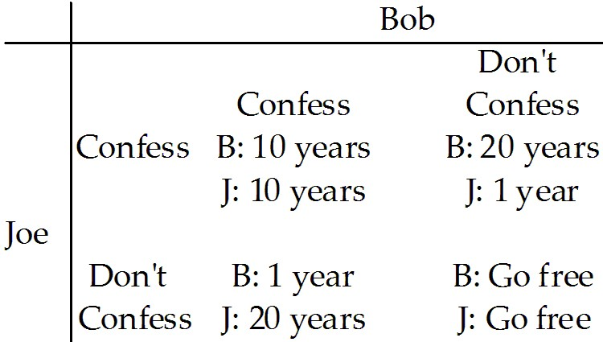

3) Refer to Table 15.2.1. This table includes the sentences that Bob and Joe will receive if convicted. They have been apprehended by the police under the suspicion of committing armed robbery. The two are immediately separated and questioned about the case. Which one of the following observations is correct?
A) Bob would be smart to confess no matter what Joe does.
B) Joe would be smart not to confess no matter what Bob does.
C) Both Bob and Joe would be better off not confessing if they both do not confess.
D) Both Bob and Joe would be better off "coming clean" and confessing to their crime.
E) Both Bob and Joe have a dominant strategy of not confessing.
Answer: C
Diff: 2 Type: MC
Topic: Oligopoly Games
4) Refer to Table 15.2.1. This table includes the sentences that Bob and Joe will receive if convicted. They have been apprehended by the police under the suspicion of committing armed robbery. The two are immediately separated and questioned about the case. Which one of the following observations is correct?
A) If Joe confesses, Bob would be better off not confessing.
B) If Bob confesses, Joe would be better off confessing.
C) The outcome of the game, assuming Joe and Bob cannot collude, is they will both go free.
D) If Joe does not confess, Bob would be better off confessing.
E) The outcome of the game, assuming Joe and Bob cannot collude, is they will both confess.
Answer: B
Diff: 2 Type: MC
Topic: Oligopoly Games

5) Which one of the following is not a feature common to all games?
A) rules
B) collusion
C) strategies
D) payoffs
E) an outcome
Answer: B
Diff: 2 Type: MC
Topic: Oligopoly Games

6) In the prisoners' dilemma with players Art and Bob, each prisoner would be best off if
A) both prisoners confess.
B) both prisoners deny.
C) Art denies and Bob confesses.
D) Bob denies and Art confesses.
E) none of the above is done.
Answer: B
Diff: 2 Type: MC
Topic: Oligopoly Games

7) In the prisoners' dilemma, with players Art and Bob, the dominant strategy equilibrium is that
A) both prisoners confess.
B) neither prisoner confesses.
C) Art denies and Bob confesses.
D) Art denies if Bob denies, and Art confesses if Bob confesses.
E) Bob denies and Art confesses.
Answer: A
Diff: 2 Type: MC
Topic: Oligopoly Games

8) A dominant strategy equilibrium occurs when
A) there is a clear strategy for each player independent of the other player's actions.
B) each player takes the best possible action given the other player's action.
C) each player complies with the collusive agreement.
D) you cooperate until the other player cheats, and then you cheat forever.
E) the outcome is the best possible.
Answer: A
Diff: 3 Type: MC
Topic: Oligopoly Games
9) A Nash equilibrium occurs when
A) there is a clear strategy for each player independent of the other player's actions.
B) each player takes the best possible action given the other player's action.
C) each player complies with the collusive agreement.
D) you cooperate until the other player cheats, and then you cheat forever.
E) jail time is minimized.
Answer: B
Diff: 3 Type: MC
Topic: Oligopoly Games

10) For a cartel to succeed,
A) it does not need the cooperation of a majority of firms in the industry.
B) there must be free entry of rival firms.
C) consumers must have alternative products available to satisfy the same need.
D) no major producer can remain outside the agreement of the cartel.
E) the industry must have an elastic demand.
Answer: D
Diff: 2 Type: MC
Topic: Oligopoly Games

11) Once a cartel determines the profit-maximizing price,
A) all members of the cartel have a strong incentive to abide by the agreed-upon price.
B) each member will face the temptation to cheat on the cartel price to increase its sales and profit.
C) changes in the output of any member firms will have no impact on the market price.
D) entry into the industry of rival firms will have no impact on the profit of the cartel.
E) entry into the industry of rival firms will raise cartel profit as long as the new firms join the cartel.
Answer: B
Diff: 2 Type: MC
Topic: Oligopoly Games

12) In a cartel, the incentive to cheat is significant because
A) each individual member has the incentive to restrict its own output to maximize profit.
B) the marginal cost is equal to the cartel price at the profit-maximizing output level.
C) each firm has the incentive to lower its price to sell more than the allotted amount.
D) each firm has the incentive to cheat by raising its price to maximize profit.
E) price is less than marginal cost for each member of the cartel.
Answer: C
Diff: 2 Type: MC
Topic: Oligopoly Games

13) If there is a successful collusive agreement in a duopoly to maximize profit,
A) the market price will equal the marginal cost of production.
B) the market price will equal the average total cost of production.
C) the price will be the same as the price in a perfectly competitive market.
D) the price will be the monopoly price.
E) the market marginal revenue will be the same as the demand curve.
Answer: D
Diff: 2 Type: MC
Topic: Oligopoly Games
14) If a duopoly collusive agreement is made that maximizes joint profit,
A) each of the duopolists has no incentive to cheat on the agreement.
B) each duopolist has the incentive to cheat on the duopoly agreement by lowering the price.
C) each duopolist has the incentive to cheat on the agreement by increasing the price to make monopoly profit.
D) there is no concern over the entrance of potential rivals, since they cannot decrease the duopolists' profit.
E) the dominant strategy is to collude.
Answer: B
Diff: 3 Type: MC
Topic: Oligopoly Games

15) Consider a duopoly with collusion. If the duopoly maximizes profit,
A) each firm will produce the same amount.
B) each firm will produce its maximum output possible.
C) industry marginal revenue will equal industry marginal cost at the level of total output.
D) industry demand will equal industry marginal cost at the level of total output.
E) price equals average total cost.
Answer: C
Diff: 2 Type: MC
Topic: Oligopoly Games

16) The firms Trick and Gear form a cartel to collude to maximize profit. If this game is nonrepeated, the Nash equilibrium is
A) both firms cheat on the agreement.
B) both firms comply with the agreement.
C) Trick cheats, while Gear complies with the agreement.
D) Gear cheats, while Trick complies with the agreement.
E) unknown.
Answer: A
Diff: 3 Type: MC
Topic: Oligopoly Games
Use the table below to answer the following questions.

Table 15.2.2

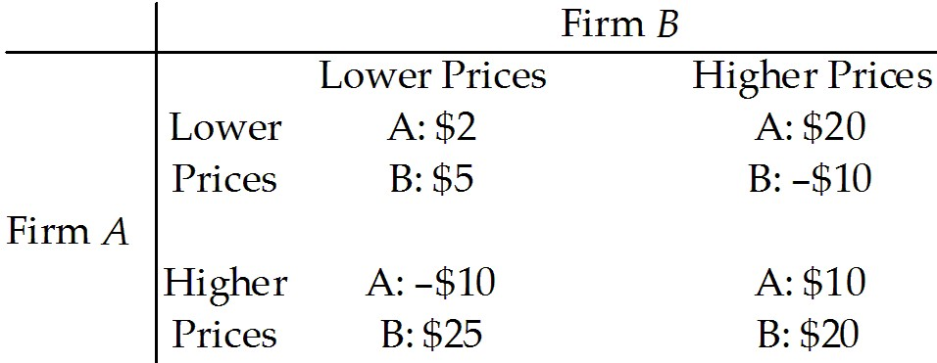

17) Table 15.2.2 gives the payoff matrix in terms of economic profit for firms A and B when there are two strategies facing each firm: (1) charge a low price, or (2) charge a high price. The equilibrium in this game (played once) will be a dominant strategy equilibrium because
A) firm B will reduce profit by more than A if both charge a lower price.
B) firm B is the dominant firm.
C) the best strategy for each firm does not depend on the strategy chosen by the other firm.
D) there is no credible threat by either firm to "punish" the other if it breaks the agreement.
E) each firm will charge the higher price.
Answer: C
Diff: 3 Type: MC
Topic: Oligopoly Games

18) Table 15.2.2 gives the payoff matrix in terms of economic profit for firms A and B when there are two strategies facing each firm: (1) charge a low price, or (2) charge a high price. Refer to the nonrepeated game in the table. In Nash equilibrium, firm A will make an economic profit of
A) -$10.
B) $2.
C) $10.
D) $20.
E) $5.
Answer: B
Diff: 3 Type: MC
Topic: Oligopoly Games

19) Table 15.2.2 gives the payoff matrix in terms of economic profit for firms A and B when there are two strategies facing each firm: (1) charge a low price, or (2) charge a high price. Refer to the nonrepeated game in the table. If both firms could successfully collude, what would be firm A's economic profit?
A) -$10
B) $2
C) $10
D) $20
E) $5
Answer: C
Diff: 3 Type: MC
Topic: Oligopoly Games
20) Consider a cartel consisting of several firms that is maximizing economic profit. If one firm cheats on the cartel agreement by cutting its price and increasing its output, the best response of the other firms is to
A) cancel the cheating firm's membership in the cartel.
B) continue to sell at the agreed-upon price.
C) raise their price to recapture lost profit.
D) cut their prices also.
E) cut output to keep total cartel output at its original level.
Answer: D
Diff: 2 Type: MC
Topic: Oligopoly Games

21) It is difficult to maintain a cartel for a long period of time. Which one of the following is the most important reason?
A) Each firm has an incentive to collude.
B) Other firms will enter the industry.
C) Firms in the cartel will want to raise the price.
D) Consumers will eventually decide not to buy the cartel's output.
E) Each firm has an incentive to cheat.
Answer: E
Diff: 2 Type: MC
Topic: Oligopoly Games

22) There exists an incentive to cheat on a collusive agreement as long as
A) price equals marginal cost.
B) price equals marginal revenue.
C) price exceeds marginal cost.
D) price is above minimum average total cost.
E) the market is perfectly competitive.
Answer: C
Diff: 3 Type: MC
Topic: Oligopoly Games
Use the table below to answer the following question.

Table 15.2.3

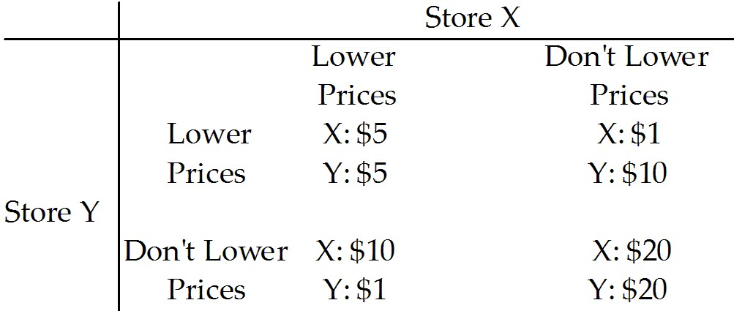

23) Refer to Table 15.2.3. Store X and Store Y must decide whether or not to lower their prices. The table gives the economic profit made by Store X and Store Y. Which one of the following observations is correct?
A) Both Store X and Store Y have a dominant strategy of raising their prices.
B) If Store X lowers its prices and Store Y does not, Store X will earn a $20 profit.
C) If Store Y lowers its prices, Store X will be better off not lowering its prices.
D) Both Store X and Store Y would be better off if they could collude and agree to not lower prices.
E) Both Store X and Store Y have a dominant strategy of lowering their prices.
Answer: D
Diff: 3 Type: MC
Topic: Oligopoly Games

24) In the research and development game of chicken,
A) the best strategy for each player is to undertake research and development.
B) the best strategy is for neither player to undertake research and development.
C) the equilibrium is for only one firm to undertake research and development.
D) the equilibrium is unique.
E) no solution can be found.
Answer: C
Diff: 3 Type: MC
Topic: Oligopoly Games
Use the table below to answer the following questions.

Table 15.2.4

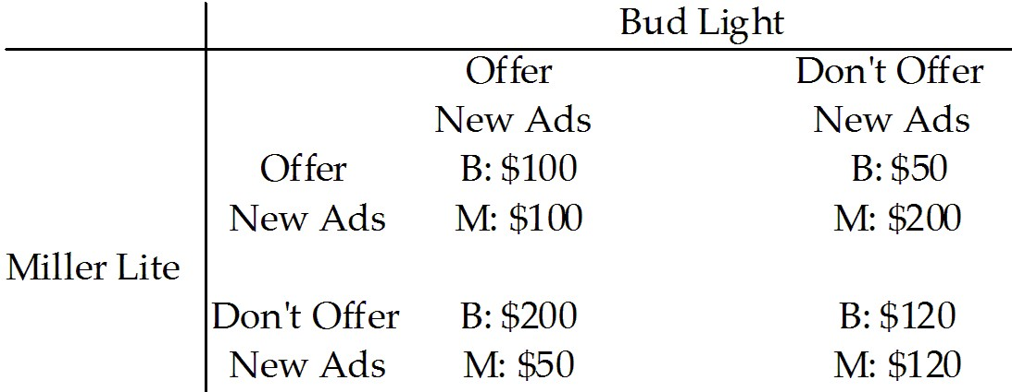

25) Refer to Table 15.2.4 The marketers of Budweiser Light beer and Miller Lite beer must decide whether or not to offer new advertising campaigns promoting their products. The payoffs in the table are the economic profit made by Bud and Miller. Which one of the following observations is correct?
A) This is not a game described as a prisoners' dilemma.
B) If Bud offers a new advertising campaign and Miller does not, Bud will make a $200 profit.
C) Miller has a dominant strategy but Bud does not.
D) Both Bud and Miller would be better off if they could collude and both offer new ads.
E) If Miller offers a new advertising campaign and Bud does not, Bud will make a $100 profit.
Answer: B
Diff: 3 Type: MC
Topic: Oligopoly Games

26) Refer to Table 15.2.4. The marketers of Budweiser Light beer and Miller Lite beer must decide whether or not to offer new advertising campaigns promoting their products. The payoffs in the table are the economic profit made by Bud and Miller. Which one of the following observations is correct?
A) This game has no dominant strategies.
B) This game has no Nash equilibrium.
C) Miller has a dominant strategy but Bud does not.
D) Bud has a dominant strategy but Miller does not.
E) Bud and Miller each have a dominant strategy.
Answer: E
Diff: 3 Type: MC
Topic: Oligopoly Games
27) Refer to Table 15.2.4. The marketers of Budweiser Light beer and Miller Lite beer must decide whether or not to offer new advertising campaigns promoting their products. The payoffs in the table are the economic profit made by Bud and Miller. Which one of the following observations is correct?
A) The equilibrium of the game is that both firms will conduct new advertising campaigns.
B) The equilibrium of the game is that neither firm will conduct a new advertising campaign.
C) The equilibrium solution has Bud conducting a new advertising campaign, but not Miller.
D) The equilibrium solution has Miller conducting a new advertising campaign, but not Bud.
E) There is no equilibrium to this game—the industry will have alternating cycles of advertising and no advertising.
Answer: A
Diff: 3 Type: MC
Topic: Oligopoly Games

28) Refer to Table 15.2.4. The marketers of Budweiser Light beer and Miller Lite beer must decide whether or not to offer new advertising campaigns promoting their products. The payoffs in the table are the economic profit made by Bud and Miller. Which one of the following observations is correct?
A) This is a game described as a prisoners' dilemma.
B) If Bud offers a new advertising campaign and Miller does not, Bud will earn a $100 profit.
C) If Bud offers a new advertising campaign, then Miller will be better off by not offering a new advertising campaign.
D) Both Bud and Miller would be better off if they could collude and agree to coordinate their new advertising campaigns.
E) If Miller does not offer a new advertising campaign, then Bud is better off if it doesn't offer a new advertising campaign.
Answer: A
Diff: 3 Type: MC
Topic: Oligopoly Games
Use the table below to answer the following questions.

Table 15.2.5

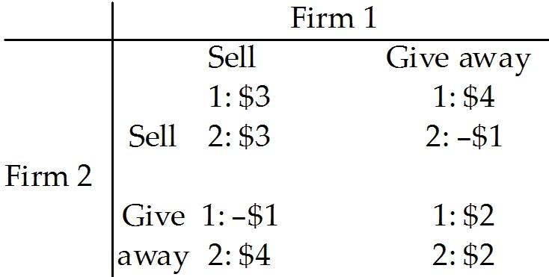

29) Refer to Table 15.2.5. Two software firms have developed an identical new software application. They are debating whether to give the new application away free and then sell add-ons or sell the application at $30 a copy. The payoff matrix is above and the payoffs are profits in millions of dollars. What is Firm 1's best strategy?
A) Give away the application regardless of what Firm 2 does.
B) Sell the application at $30 a copy regardless of what Firm 2 does.
C) Give away the application only if Firm 2 sells the application.
D) Give away the application only if Firm 2 gives away the application.
E) Sell the application only if Firm 2 sells the application.
Answer: A
Diff: 3 Type: MC
Topic: Oligopoly Games

30) Refer to Table 15.2.5. Two software firms have developed an identical new software application. They are debating whether to give the new application away free and then sell add-ons or sell the application at $30 a copy. The payoff matrix is above and the payoffs are profits in millions of dollars. What is the Nash equilibrium of the game?
A) Both Firm 1 and 2 will sell the software application at $30 a copy.
B) Both Firm 1 and 2 will give the software application away free.
C) Firm 1 will give the application away free and Firm 2 will sell it at $30.
D) Firm 1 will sell the application for $30 and Firm 2 will give it away.
E) There is no Nash equilibrium to this game.
Answer: B
Diff: 3 Type: MC
Topic: Oligopoly Games
Refer to the table below to answer the following questions.

Table 15.2.6

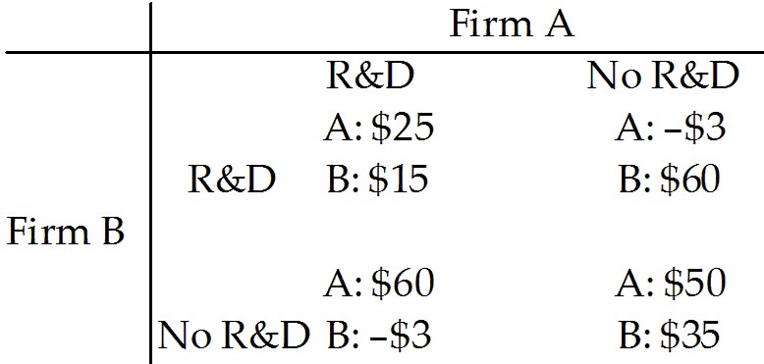

31) Refer to Table 15.2.6. Firms A and B can conduct research and development (R&D) or not conduct it. R&D is costly but can increase the quality of the product and increase sales. The payoff matrix is the economic profits of the two firms and is given above, where the numbers are millions of dollars. A's best strategy is to
A) conduct R&D regardless of what B does.
B) not conduct R&D regardless of what B does.
C) conduct R&D only if B conducts R&D.
D) conduct R&D only if B does not conduct R&D.
E) not conduct R&D only if B does not conduct R&D.
Answer: A
Diff: 2 Type: MC
Topic: Oligopoly Games

32) Refer to Table 15.2.6. Firms A and B can conduct research and development (R&D) or not conduct it. R&D is costly but can increase the quality of the product and increase sales. The payoff matrix is the economic profits of the two firms and is given above, where the numbers are millions of dollars. The Nash equilibrium
A) occurs when both A and B conduct R&D.
B) occurs when only A conducts R&D.
C) occurs when only B conducts R&D.
D) occurs when neither A nor B conduct R&D.
E) does not occur
Answer: A
Diff: 2 Type: MC
Topic: Oligopoly Games
Refer to the table below to answer the following questions.

Table 15.2.7

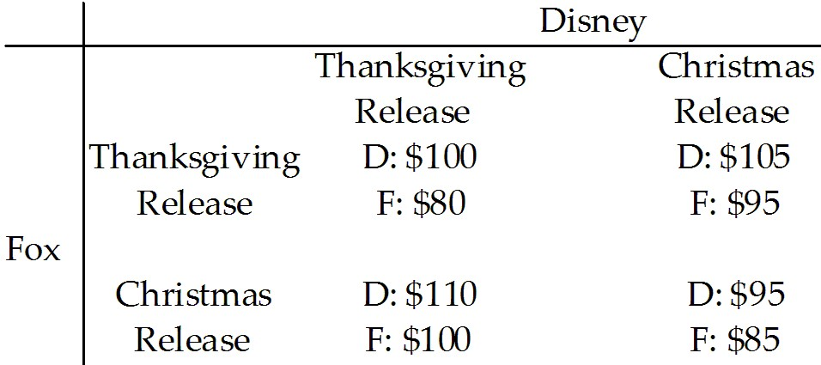

33) Refer to Table 15.2.7. Disney and Fox must decide when to release their next films. The revenues received by each studio depend in part on when the other studio releases its film. Each studio can release its film at Thanksgiving or at Christmas. The revenues received by each studio, in millions of dollars, are given in the payoff matrix above. Which of the following statements correctly describes Fox's strategy given what Disney's release choice may be?
A) If Disney chooses a Thanksgiving release, Fox should choose a Christmas release.
B) If Disney chooses a Christmas release, Fox should choose a Thanksgiving release.
C) Fox should release on Christmas regardless of what Disney does.
D) Fox should release on Thanksgiving regardless of what Disney does.
E) Both answers A and B are correct.
Answer: E
Diff: 2 Type: MC
Topic: Oligopoly Games

34) Refer to Table 15.2.7. Disney and Fox must decide when to release their next films. The revenues received by each studio depend in part on when the other studio releases its film. Each studio can release its film at Thanksgiving or at Christmas. The revenues received by each studio, in millions of dollars, are given in the payoff matrix above. Which of the following statements correctly describes Disney's strategy given what Fox's release choice may be?
A) If Fox chooses a Thanksgiving release, Disney should choose a Christmas release.
B) If Fox chooses a Christmas release, Disney should choose a Thanksgiving release.
C) Disney should release on Thanksgiving regardless of what Fox does.
D) Disney should release on Christmas regardless of what Fox does.
E) Both answers A and B are correct.
Answer: E
Diff: 2 Type: MC
Topic: Oligopoly Games
Refer to the table below to answer the following questions.

Table 15.2.8

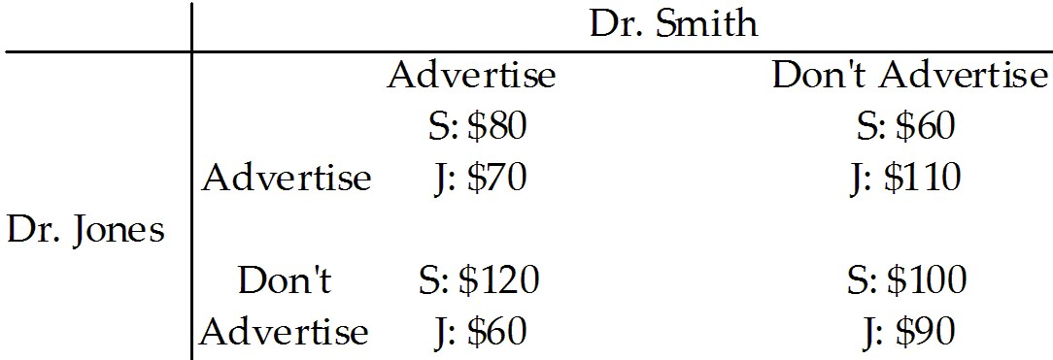

35) Refer to Table 15.2.8. Libertyville has two optometrists, Dr. Smith and Dr. Jones. Each optometrist can choose to advertise his service or not. The incomes of each optometrist, in thousands of dollars, are given in the payoff matrix above. Which of the following statements correctly describes Dr. Smith's strategy given what Dr. Jones may do?
A) Dr. Smith advertises no matter what Dr. Jones does.
B) Dr. Smith does not advertise no matter what Dr. Jones does.
C) Dr. Smith advertises only if Dr. Jones doesn't advertise.
D) Dr. Smith advertises only if Dr. Jones advertises.
E) Dr. Smith does not advertise if Dr. Jones advertises.
Answer: A
Diff: 2 Type: MC
Topic: Oligopoly Games

36) Refer to Table 15.2.8. Libertyville has two optometrists, Dr. Smith and Dr. Jones. Each optometrist can choose to advertise his service or not. The incomes of each optometrist, in thousands of dollars, are given in the payoff matrix above. Which of the following statements correctly describes Dr. Jones' strategy given what Dr. Smith may do?
A) Dr. Jones advertises no matter what Dr. Smith does.
B) Dr. Jones does not advertise no matter what Dr. Smith does.
C) Dr. Jones advertises only if Dr. Smith doesn't advertise.
D) Dr. Jones advertises only if Dr. Smith advertises.
E) Dr. Jones does not advertise if Dr. Smith advertises.
Answer: A
Diff: 2 Type: MC
Topic: Oligopoly Games

37) Refer to Table 15.2.8. Libertyville has two optometrists, Dr. Smith and Dr. Jones. Each optometrist can choose to advertise his service or not. The incomes of each optometrist, in thousands of dollars, are given in the payoff matrix above. Which of the following statements correctly categorizes the Nash equilibrium for the game?
A) The game has a Nash equilibrium in which both optometrists advertise.
B) The game has a Nash equilibrium in which both optometrists do not advertise.
C) The game has a Nash equilibrium in which Dr. Smith advertises and Dr. Jones does not advertise.
D) The game has a Nash equilibrium in which Dr. Smith does not advertise and Dr. Jones does advertise.
E) The game has no Nash equilibrium.
Answer: A
Diff: 2 Type: MC
Topic: Oligopoly Games
Refer to the table below to answer the following question.

Table 15.2.9

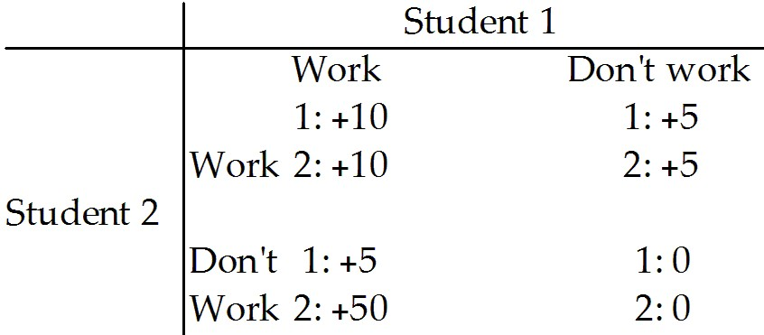

38) Refer to Table 15.2.9. Two students are assigned a group project. Each has the option to work or not work to achieve a high grade. The payoffs are shown in the above table. Student 1
A) works only if student 2 works.
B) works regardless of the decision made by student 2.
C) does not work if student 2 works.
D) does not work regardless of what student 2 decides.
E) works only if student 2 does not work.
Answer: B
Diff: 2 Type: MC
Topic: Oligopoly Games

Refer to the table below to answer the following questions.

Table 15.2.10

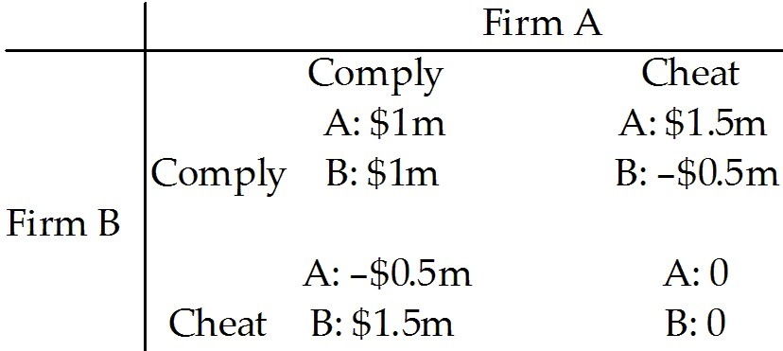

39) Refer to Table 15.2.10. Firm A and Firm B are the only producers of soap powder. They collude and agree to share the market equally. The payoff matrix shows the game they play. The equilibrium of the game is that Firm A ________ and Firm B ________.
A) complies; cheats
B) cheats; complies
C) complies; complies
D) cheats; cheats
E) makes an economic profit; incurs an economic loss
Answer: D
Diff: 3 Type: MC
Topic: Oligopoly Games
Source: MyEconLab
40) Refer to Table 15.2.10. Firm A and Firm B are the only producers of soap powder. They collude and agree to share the market equally. The equilibrium ________ a dominant strategy equilibrium because the strategy in this game is for a firm ________.
A) is; to comply regardless of the other firm's choice
B) is not; to comply when the other firm cheats and to cheat when the other firm complies
C) is; to cheat regardless of the other firm's choice
D) is not; to comply when the other firm complies and to cheat when the other firm cheats
E) is; to comply when the other firm cheats and to cheat when the other firm complies
Answer: C
Diff: 3 Type: MC
Topic: Oligopoly Games
Source: MyEconLab

41) The equilibrium strategy for each firm in a duopolist's dilemma is to ________. Firms ________ succeed in raising price and profits because each firm ________.
A) comply; do not; makes a smaller economic profit if it complies with the agreement, but complying with the agreement is in the social interest, and most firms support the social interest
B) comply; do; makes greater economic profit if it complies with the agreement, regardless of how the other firm acts
C) cheat; do not; makes greater economic profit if it cheats on the agreement, regardless of how the other firm acts
D) cheats; do; makes greater economic profit if it cheats on the agreement, regardless of how the other firm acts
E) cheat; do; refuses to sell at any price below the monopoly price
Answer: C
Diff: 3 Type: MC
Topic: Oligopoly Games
Source: MyEconLab

42) In a prisoners' dilemma game, which of the following strategies gives the best outcome for both prisoners?
A) Both players deny.
B) Both players confess.
C) One player confesses and the other player denies.
D) Both players hire good lawyers.
E) None of the above
Answer: A
Diff: 1 Type: MC
Topic: Oligopoly Games
43) Caven and John have been arrested by the police, who have evidence that will convict them of robbing a bank. If convicted, each will receive a sentence of 6 years for the robbery. During questioning, the police suspect that Caven and John are responsible for a series of bank robberies. If both confess to the series, each will receive 12 years in jail. If only one confesses, he will receive 4 years and the one who does not confess will receive 14 years. What is the equilibrium for this game?
A) Both deny.
B) Caven confesses and John denies.
C) John confesses and Caven denies.
D) Both confess.
E) Both serve 8 years in jail.
Answer: D
Diff: 2 Type: MC
Topic: Oligopoly Games

44) Two firms, Alpha and Beta, produce identical computer hard drives. They have identical costs, and the hard drives they produce are identical. The industry is a natural duopoly. Alpha and Beta enter into a collusive agreement, according to which they split the market equally. If both firms comply with the agreement,
A) together they will produce the monopoly quantity and make the monopoly economic profit.
B) the price of a hard drive will equal marginal cost.
C) each firm will make zero economic profit.
D) the oligopoly will produce more hard drives than a profit-maximizing monopoly would produce.
E) the oligopoly will produce fewer hard drives than a profit-maximizing monopoly would produce.
Answer: A
Diff: 2 Type: MC
Topic: Oligopoly Games

45) Two firms, Alpha and Beta, produce identical computer hard drives. They have identical costs, and the hard drives they produce are identical. The industry is a natural duopoly. Alpha and Beta enter into a collusive agreement, according to which they split the market equally. If both firms cheat on the agreement so the market is the same as a competitive market,
A) each firm makes zero economic profit in the long run.
B) each firm makes the monopoly profit.
C) the oligopoly will produce fewer hard drives than a profit-maximizing monopoly would produce.
D) the oligopoly will produce the same number of hard drives as a profit-maximizing monopoly would produce.
E) each firm incurs an economic loss and exits the market in the long run.
Answer: A
Diff: 2 Type: MC
Topic: Oligopoly Games
46) The maximum total economic profit that can be made by colluding duopolists
A) equals the economic profit made by a monopoly.
B) exceeds the economic profit made by a monopoly.
C) is less than the economic profit made by a monopoly.
D) is zero.
E) cannot be determined.
Answer: A
Diff: 3 Type: MC
Topic: Oligopoly Games

47) Two firms are trying to decide how much to budget for research and development. Once a new discovery is made, each firm benefits regardless of which firm developed the innovation. In this R&D game of chicken, the Nash equilibrium is that
A) both firms conduct R&D.
B) neither firm conducts R&D.
C) only one firm conducts R&D but which firm conducts the R&D cannot be determined.
D) the larger firm conducts the R&D.
E) the smaller firm conducts the R&D.
Answer: C
Diff: 2 Type: MC
Topic: Oligopoly Games

Use the information below to answer the following questions.

Fact 15.2.1

Two firms, FastNet and SmartCast are the only Internet providers in a city. They have identical costs and one firm's service is a perfect substitute for the other firm's service. The industry is a natural duopoly. FastNet and SmartCast decide to collude and agree to share the market equally.

48) Refer to Fact 15.2.1. Which of the following actions maximizes the industry's economic profit?
A) Both firms cheat on the agreement.
B) One firm cheats and one firm complies.
C) Both firms comply with the agreement.
D) New firms enter the market.
E) Both firms charge the price that would exist in a perfectly competitive market.
Answer: C
Diff: 2 Type: MC
Topic: Oligopoly Games

49) Refer to Fact 15.2.1. What is the Nash equilibrium?
A) Both firms cheat on the agreement.
B) One firm cheats and one firm complies.
C) Both firms comply with the agreement.
D) New firms enter the market.
E) Both firms charge the price that would exist in a perfectly competitive market.
Answer: A
Diff: 2 Type: MC
Topic: Oligopoly Games
50) Refer to Fact 15.2.1. What is the result if both firms cheat on the agreement?
A) Both firms make an economic profit that is less than if they had both complied with the agreement.
B) Economic profit of both firms is maximized.
C) Both firms are playing a game of chicken.
D) Only one firm is playing a game of chicken.
E) Market output decreases.
Answer: A
Diff: 2 Type: MC
Topic: Oligopoly Games

51) In a duopoly game, we observe the following payouts. If the two firms collude they each make an economic profit of $50,000. If one firm cheats, then that firm makes an economic profit of $60,000 and the other incurs an economics loss of $10,000. If both firms cheat, then they both make zero economic profit. What is the Nash equilibrium?
A) Both firms cheat.
B) Neither firm cheats.
C) One firm cheats but we don't know which one.
D) Only the larger firm cheats.
E) Only the smaller firm cheats.
Answer: A
Diff: 1 Type: MC
Topic: Oligopoly Games

15.3 Repeated Games and Sequential Games

1) Consider a "prisoners' dilemma" game consisting of two firms in collusion to maximize profit. The game is repeated indefinitely and each player employs a tit-for-tat strategy. The equilibrium when the two firms share the monopoly profit is called a
A) credible strategy equilibrium.
B) dominant player equilibrium.
C) duopoly equilibrium.
D) trigger strategy equilibrium.
E) cooperative equilibrium.
Answer: E
Diff: 3 Type: MC
Topic: Repeated Games and Sequential Games
Use the table below to answer the following question.

Table 15.3.1

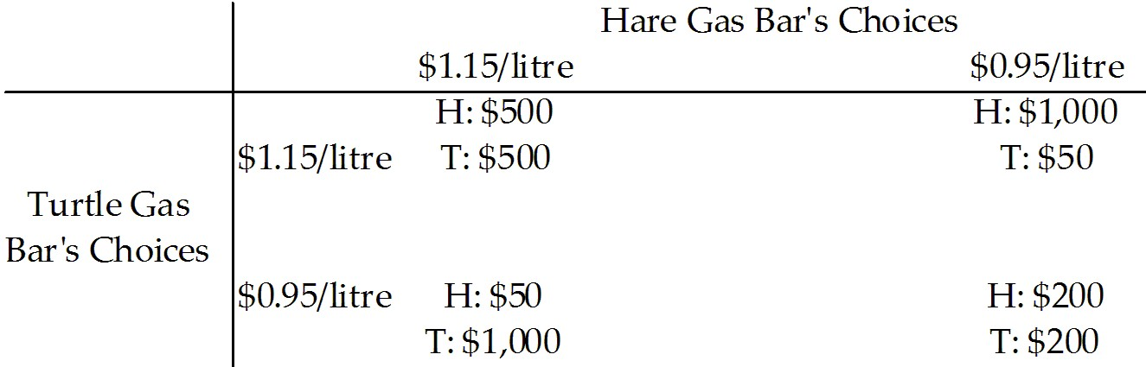

2) Consider the game shown in Table 15.3.1 based on potential gas prices between two competitors. The game is played repeatedly and the result is a cooperative equilibrium. The payoffs in the table show the economic profit of the firms. The most likely outcome is
A) a cycle of first $0.95/litre, then $1.15/litre, etc.
B) Hare sets her prices at $1.15/litre, and Turtle sets his at $0.95/litre.
C) Hare sets her prices at $0.95/litre, and Turtle sets his at $1.15/litre.
D) both set their prices at $1.15/litre.
E) both set their prices at $0.95/litre.
Answer: D
Diff: 3 Type: MC
Topic: Repeated Games and Sequential Games

3) Limit pricing is the practice of
A) limiting the amount that can be purchased to drive up prices.
B) threatening to go to the limit in a price war if someone enters your market.
C) charging a monopoly price, but producing a quantity greater than the quantity at which MC = MR.
D) setting the price at the highest level that inflicts a loss on the entrant.
E) charging a price higher than the monopoly price, but producing a quantity greater than the quantity at which MC = MR.
Answer: D
Diff: 3 Type: MC
Topic: Repeated Games and Sequential Games

4) Consider the cartel of Trick and Gear. The game is repeated indefinitely and each firm employs a tit-for-tat strategy. The equilibrium is
A) both firms cheat on the agreement.
B) both firms comply with the agreement.
C) Trick cheats and Gear complies with the agreement.
D) Gear cheats and Trick complies with the agreement.
E) one of the firms exits the market.
Answer: B
Diff: 3 Type: MC
Topic: Repeated Games and Sequential Games
5) Consider the cartel of Trick and Gear. The game is repeated indefinitely and each firm employs a tit-for-tat strategy. The equilibrium is called
A) a credible strategy equilibrium.
B) a dominant player equilibrium.
C) a duopoly equilibrium.
D) a trigger strategy equilibrium.
E) a cooperative equilibrium.
Answer: E
Diff: 3 Type: MC
Topic: Repeated Games and Sequential Games

6) Which of the following quotes shows a contestable market in the widget industry?
A) "I am producing extra widgets, even though it costs me short-run profits, to stop Wally's Widgets from expanding into my market."
B) "I am producing more widgets than Wally and I agreed to in our talk last week."
C) "If only Wally and I could agree on a higher price, we could make more profits."
D) "I have been spending extra on research and development of my new two-way widget."
E) None of the above
Answer: A
Diff: 3 Type: MC
Topic: Repeated Games and Sequential Games

7) Which of the following quotes shows cheating on a cartel in the widget industry?
A) "I am producing extra widgets, even though it costs me short-run profit, to stop Wally's Widgets from expanding into my market."
B) "I am producing more widgets than Wally and I agreed to in our talk last week."
C) "If only Wally and I could agree on a higher price, we could make more profit."
D) "I have been spending extra on research and development of my new two-way widget."
E) None of the above
Answer: B
Diff: 1 Type: MC
Topic: Repeated Games and Sequential Games

8) Limit pricing refers to
A) the highest price a monopolist can set.
B) the highest price that just inflicts a loss on a potential entrant.
C) a strategy used by entering firms in contestable markets.
D) the lowest price a duopoly can set.
E) the price set in a perfectly competitive market.
Answer: B
Diff: 2 Type: MC
Topic: Repeated Games and Sequential Games

9) A contestable market exists whenever
A) two or more firms are competing.
B) the Herfindahl-Hirschman Index exceeds 1,800.
C) the four-firm concentration ratio exceeds 50 percent.
D) a monopoly contests entry into its markets.
E) potential entry holds down prices.
Answer: E
Diff: 2 Type: MC
Topic: Repeated Games and Sequential Games
10) When a firm cooperates if the other cooperates, but plays the Nash equilibrium strategy forever if the other cheats, the strategy is a
A) dominant strategy.
B) trigger strategy.
C) tit-for-tat strategy.
D) wimp's strategy.
E) cooperative strategy.
Answer: B
Diff: 2 Type: MC
Topic: Repeated Games and Sequential Games

11) A tit-for-tat strategy can be used
A) in a single-play game or a repeated game.
B) in a single-play game but not a repeated game.
C) in a repeated game but not a single-play game.
D) in neither a repeated game nor a single-play game.
E) only when there is no Nash equilibrium.
Answer: C
Diff: 2 Type: MC
Topic: Repeated Games and Sequential Games

12) A trigger strategy can be used
A) in a single-play game or a repeated game.
B) in a single-play game but not a repeated game.
C) in a repeated game but not a single-play game.
D) in neither a single-play game nor a repeated game.
E) only when there is no Nash equilibrium.
Answer: C
Diff: 1 Type: MC
Topic: Repeated Games and Sequential Games

13) A strategy in which a player cooperates in the current period if the other player cooperated in the previous period, but the player cheats in the current period if the other player cheated in the previous period is called a
A) tit-for-tat strategy.
B) trigger strategy.
C) duopoly strategy.
D) dominant firm strategy.
E) Nash strategy.
Answer: A
Diff: 1 Type: MC
Topic: Repeated Games and Sequential Games
14) A trigger strategy is one in which a player
A) cooperates in the current period if the other player cooperated in the previous period, but cheats in the current period only if the other player cheated in the previous period.
B) cheats in the current period if the other player cooperated in the previous period, but cooperates in the current period if the other player cheated in the previous period.
C) cooperates in the current period if the other player has always cooperated, but cheats forever if the other player ever cheats.
D) cheats in the current period if the other player has always cheated, but cooperates forever if the other player has ever cooperated.
E) changes his or her strategy in a random manner.
Answer: C
Diff: 2 Type: MC
Topic: Repeated Games and Sequential Games

15) Sarah's Soothing Diapers, Inc. and Orville's Odorless Diapers, Inc. are duopolists, who have agreed to collude. Orville has decided that he will comply with the collusive agreement as long as Sarah cooperated in the previous period. But if Sarah cheated in the previous period, Orville will punish Sarah by cheating in the current period. Orville's strategy is referred to as a
A) Nash strategy.
B) tit-for-tat strategy.
C) trigger strategy.
D) monkey-see, monkey-do strategy.
E) dominant firm strategy.
Answer: B
Diff: 2 Type: MC
Topic: Repeated Games and Sequential Games

16) A market with a single firm but no barriers to entry is known as
A) a natural monopoly.
B) a contestable market.
C) a perfectly competitive market.
D) monopolistic competition.
E) an oligopoly.
Answer: B
Diff: 1 Type: MC
Topic: Repeated Games and Sequential Games

17) A market in which firms can enter and leave so easily that firms in the market face competition from potential entrants is called a
A) contestable market.
B) cartel.
C) limit pricing market.
D) monopolistic competition market.
E) natural oligopoly.
Answer: A
Diff: 1 Type: MC
Topic: Repeated Games and Sequential Games
18) Which of the following statements is TRUE about contestable markets?
A) There are significant barriers to entry.
B) Firms earn large economic profits.
C) Each firm faces a perfectly elastic demand.
D) There are few firms in the industry.
E) The Herfindahl-Hirschman Index is close to zero.
Answer: D
Diff: 1 Type: MC
Topic: Repeated Games and Sequential Games

19) A contestable market is similar to a perfectly competitive market in that there
A) are barriers to entry.
B) are no barriers to entry.
C) can be only one firm in the market.
D) will be no entry if the existing firm makes an economic profit.
E) is a perfectly elastic demand.
Answer: B
Diff: 1 Type: MC
Topic: Repeated Games and Sequential Games

20) In a contestable market the Herfindahl-Hirschman Index is ________ and the market behaves as if it is ________.
A) low; perfectly competitive
B) low; a monopoly
C) high; perfectly competitive
D) high; a monopoly
E) zero; perfectly competitive
Answer: C
Diff: 2 Type: MC
Topic: Repeated Games and Sequential Games

21) In a repeated game, punishments that result in heavy damages are an incentive for players to adopt the strategies that result in a ________ equilibrium.
A) contestable
B) strategic
C) complementary
D) cooperative
E) satisfying
Answer: D
Diff: 1 Type: MC
Topic: Repeated Games and Sequential Games

22) In a contestable market with one firm, the existing firm
A) sets its price lower than the monopoly price.
B) sets its price equal to the monopoly price.
C) sets its price above the monopoly price.
D) has no competition.
E) sets its price so that other firms will enter the market.
Answer: A
Diff: 2 Type: MC
Topic: Repeated Games and Sequential Games
23) The price in a contestable market is similar to that in a perfectly competitive market because
A) firms in the market make an economic profit in the long run.
B) there are no barriers to entry.
C) there are many firms in the market.
D) the Nash equilibrium is that all firms cheat.
E) collusion is possible.
Answer: B
Diff: 1 Type: MC
Topic: Repeated Games and Sequential Games

15.4 Anti-Combine Law

1) Anti-combine law attempts to
A) support prices.
B) establish Crown corporations.
C) prevent monopoly behaviour.
D) establish fair trade laws.
E) deregulate monopolies.
Answer: C
Diff: 1 Type: MC
Topic: Anti-Combine Law

2) Canada's anti-combine law dates from the
A) 1880s.
B) 1910s.
C) 1930s.
D) 1960s.
E) 1980s.
Answer: A
Diff: 2 Type: MC
Topic: Anti-Combine Law

3) Canada's anti-combine law is enforced by
A) a Competition Tribunal.
B) the courts.
C) Parliament.
D) A and B.
E) A and C.
Answer: D
Diff: 2 Type: MC
Topic: Anti-Combine Law

4) The Competition Act distinguishes between business practices that are criminal and noncriminal. Which of the following is noncriminal?
A) conspiracy to fix prices
B) bid-rigging
C) resale price maintenance
D) false advertising
E) refusal to deal
Answer: E
Diff: 2 Type: MC
Topic: Anti-Combine Law
5) Choose the statement below that is incorrect.
A) The Competition Act distinguishes between practices that are criminal and practices that are noncriminal.
B) The Director of the Competition Bureau sends alleged violations of a noncriminal nature to Parliament for examination.
C) The Competition Act of 1986 established a Competition Bureau.
D) The Competition Act of 1986 established a Competition Tribunal.
E) Canada's anti-combine law dates from 1889.
Answer: B
Diff: 2 Type: MC
Topic: Anti-Combine Law
Source: MyEconLab

6) Anti-combine law
A) can work in the public interest to maximize total surplus or in the self-interest of producers to maximize producer surpluses.
B) always works in the self-interest of producers to maximize producer surpluses.
C) always works in the public interest to maximize total surplus.
D) encourages oligopolies to exhibit more monopolistic behaviours.
E) is always prosecuted in Canada's criminal courts.
Answer: A
Diff: 2 Type: MC
Topic: Anti-Combine Law
Source: MyEconLab

7) All of the following except ________ are noncriminal offences under the Competition Act.
A) refusal to deal
B) mergers
C) false advertising
D) abuse of a dominant market position
E) exclusive dealing
Answer: C
Diff: 2 Type: MC
Topic: Anti-Combine Law
Source: MyEconLab

8) A merger is unlikely to be approved if
A) there are fewer than 6 firms in a market.
B) it prevents or substantially lessens competition.
C) the good produced in the market has been deemed a necessity.
D) the industry is government regulated.
E) all of the above
Answer: B
Diff: 2 Type: MC
Topic: Anti-Combine Law
Source: MyEconLab
9) The act of parliament that provides our anti-combine law is
A) the Anti-Combine Act of 1986.
B) the Anti-Combine Act of 1889.
C) the Competition Act of 1986.
D) the Competition Act of 1889.
E) the Competition Act of 1967.
Answer: C
Diff: 2 Type: MC
Topic: Anti-Combine Law
Source: MyEconLab

Use the information below to answer the following question.

Fact 15.4.1

Apple conspired with five publishers to undercut Amazon's 90 percent share of the e-book market, which caused e-book prices to rise to $12.99 or $14.99 from the $9.99 that Amazon charged.

10) Refer to Fact 15.4.1. This conspiracy to raise prices violates the anti-combine law because
A) Apple is merging with the five publishers.
B) Apple is telling the publishers the price at which they must sell e-books.
C) Apple is refusing to deal with Amazon.
D) it substantially lessens competition in the e-book market.
E) it is creating a monopoly.
Answer: D
Diff: 2 Type: MC
Topic: Anti-Combine Law
Source: MyEconLab

